https://github.com/Pri22yanshisahu/CPP-CLASS
class and objects
Exercise 1 — Basic Class
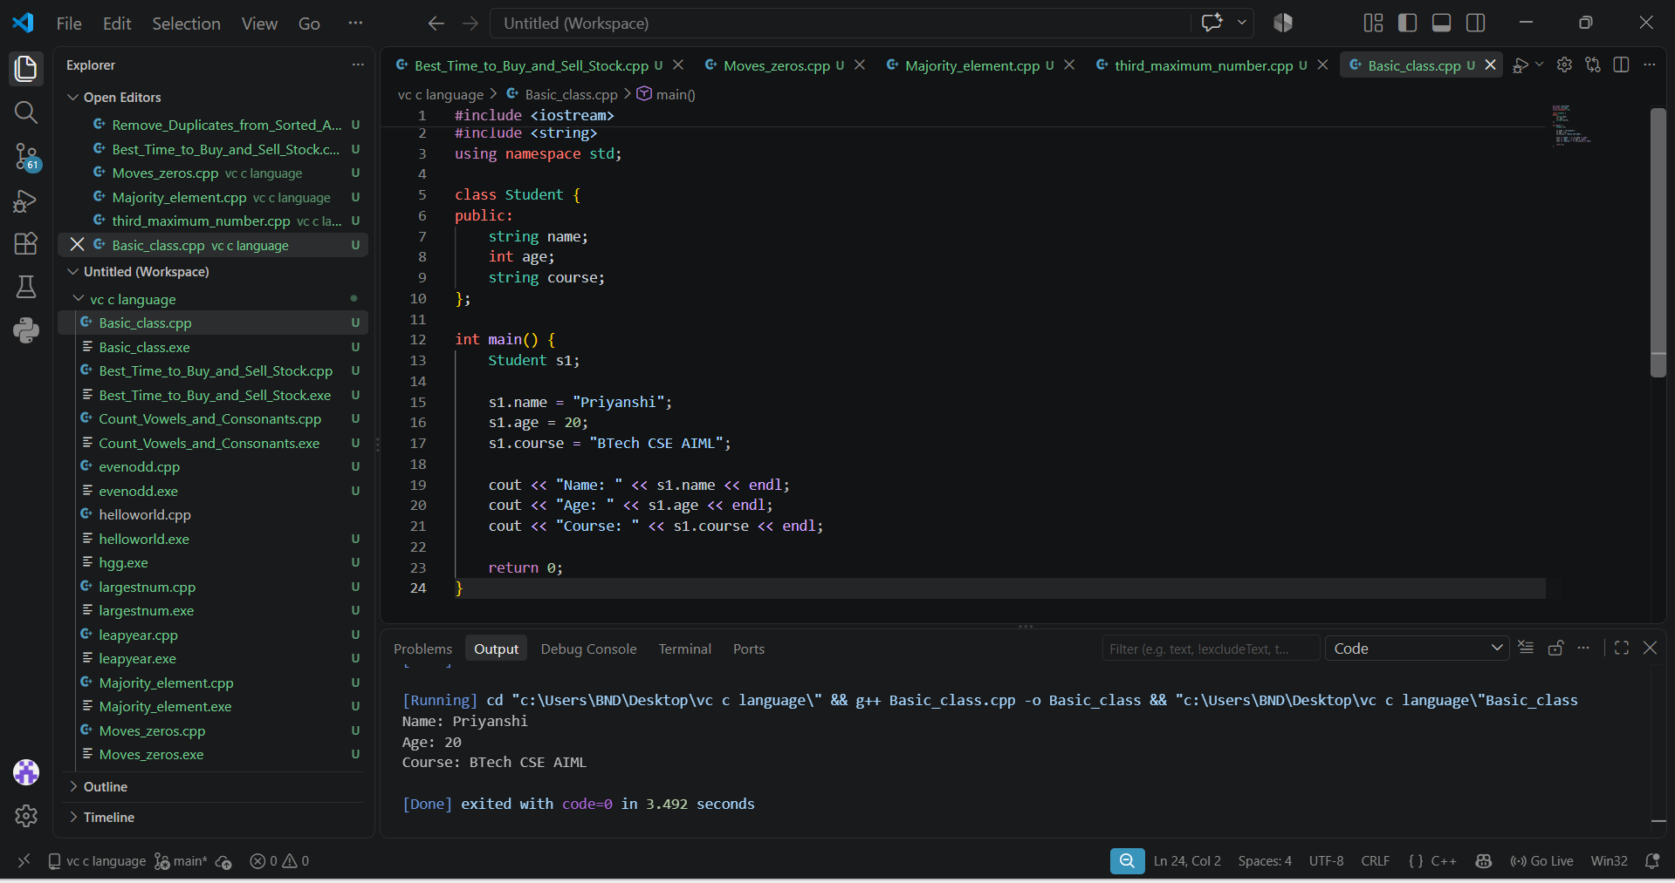
Exercise 2 — Multiple Objects
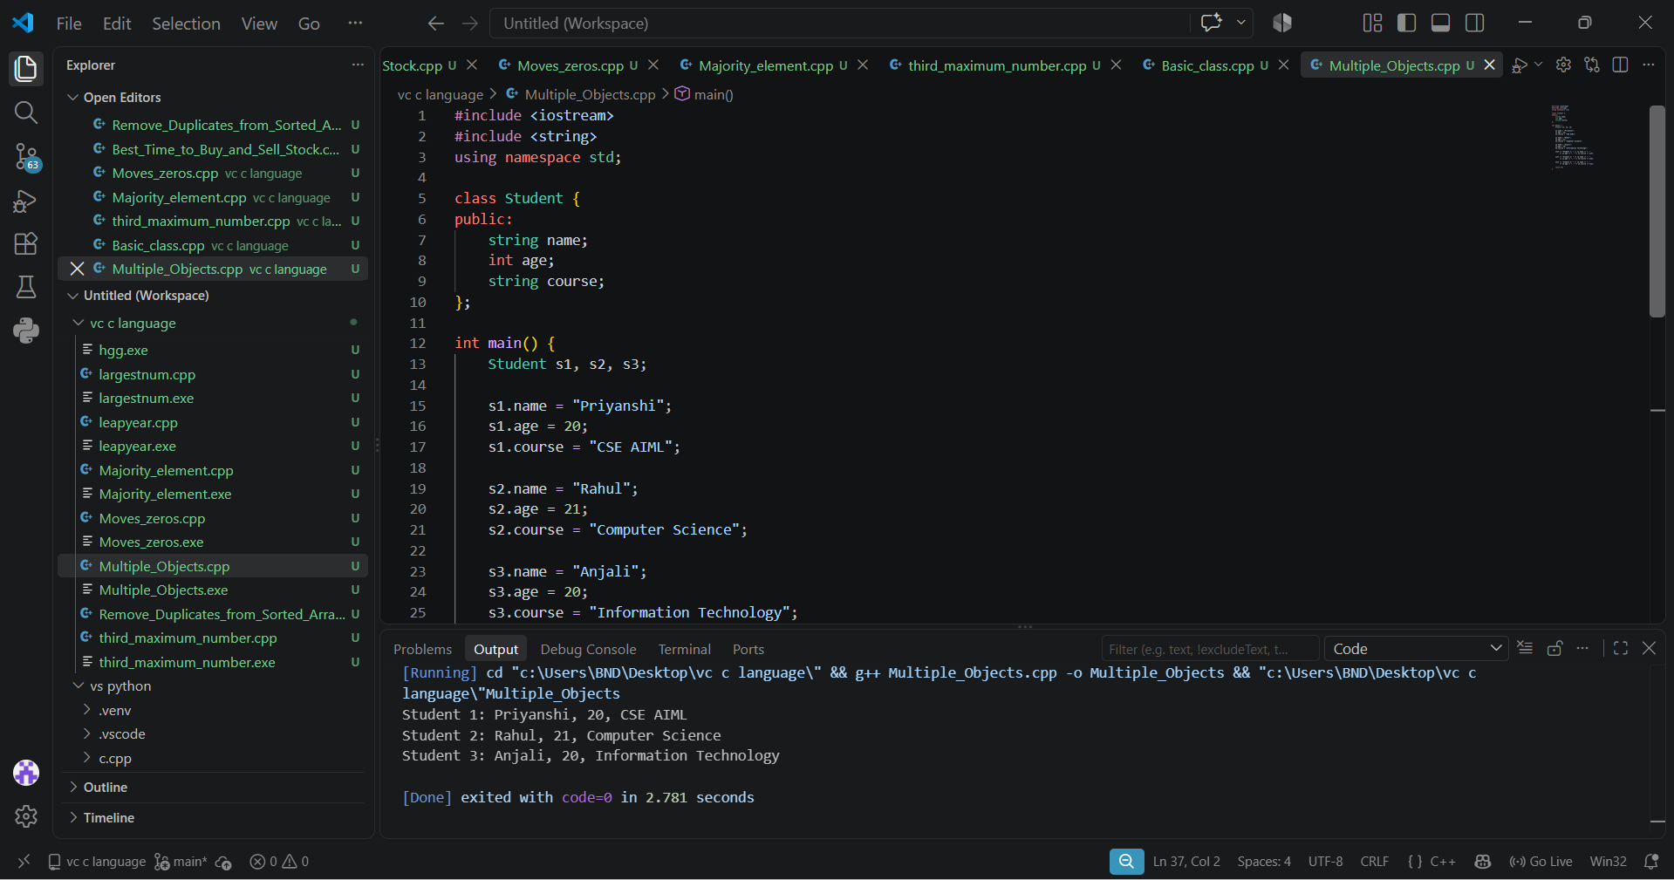
Exercise 3 — Method
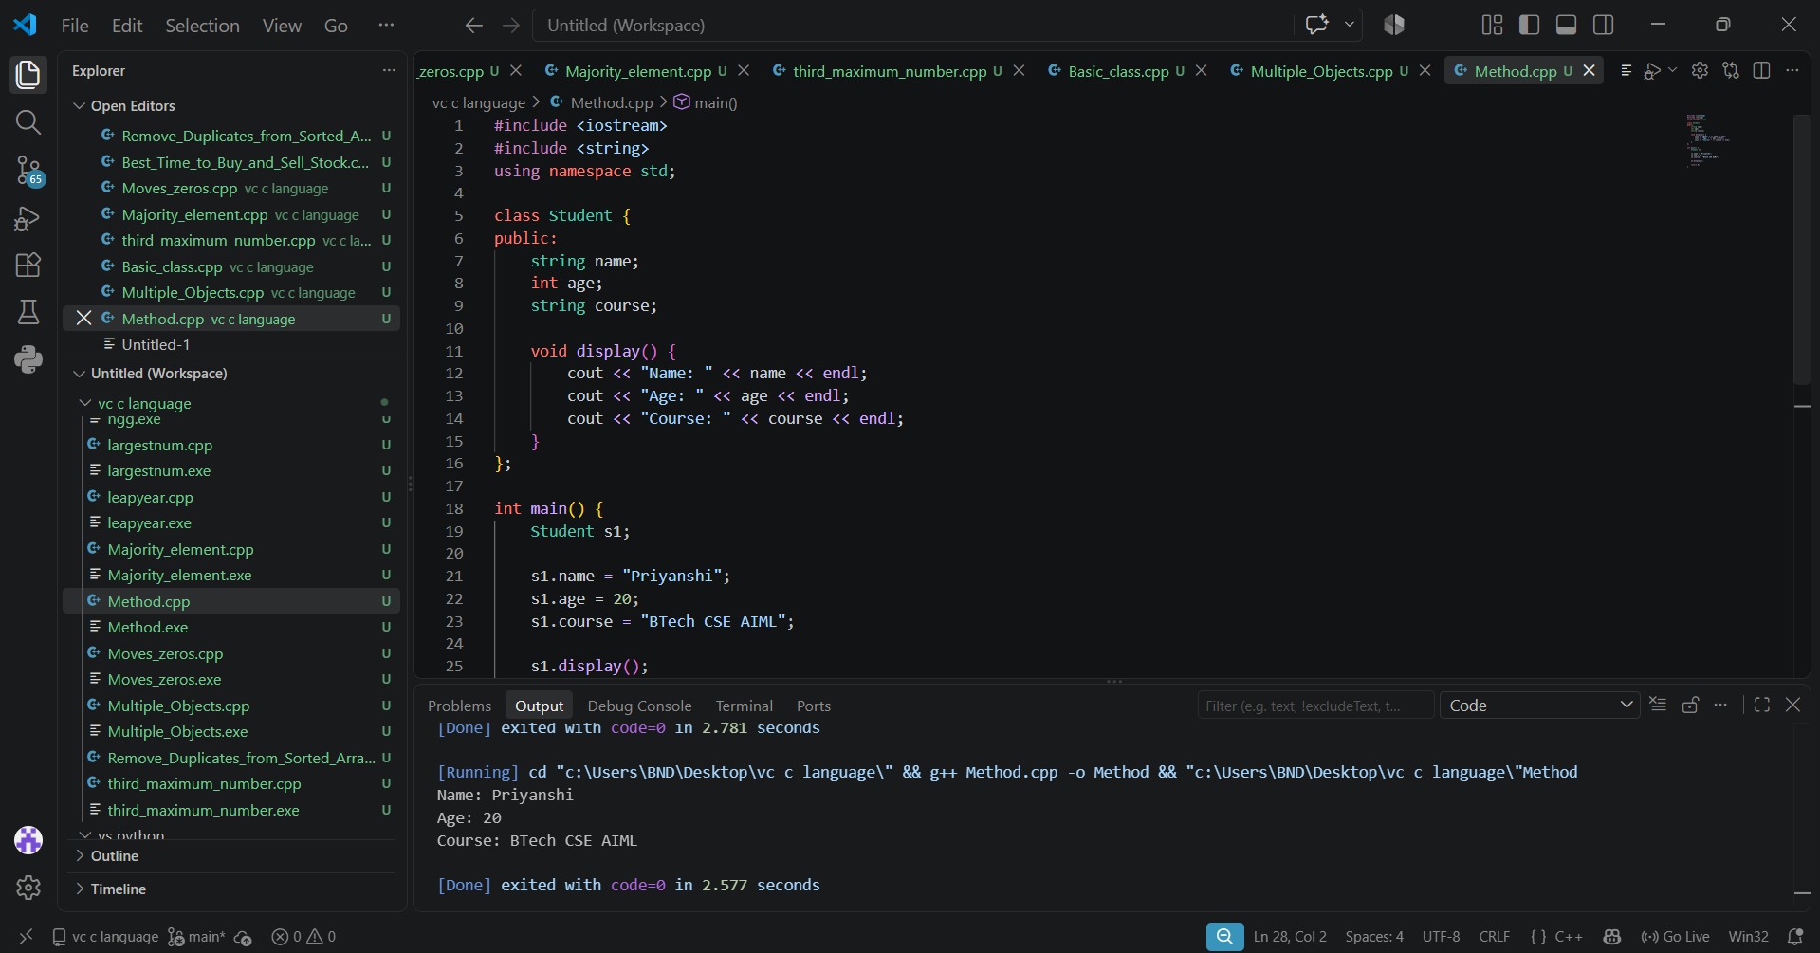
Exercise 4 — Constructor
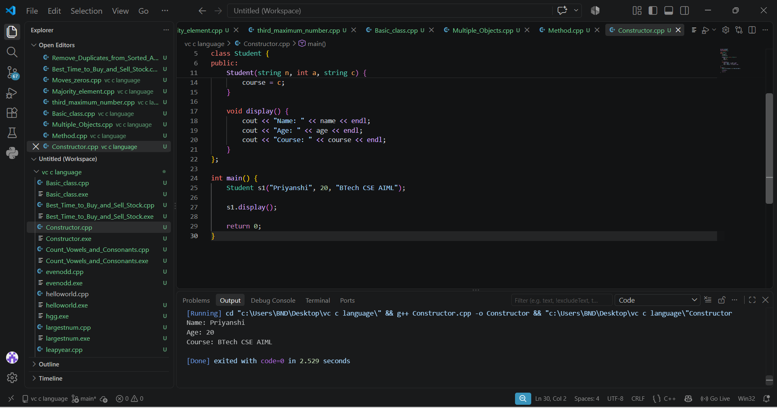
Exercise 5 — Employee
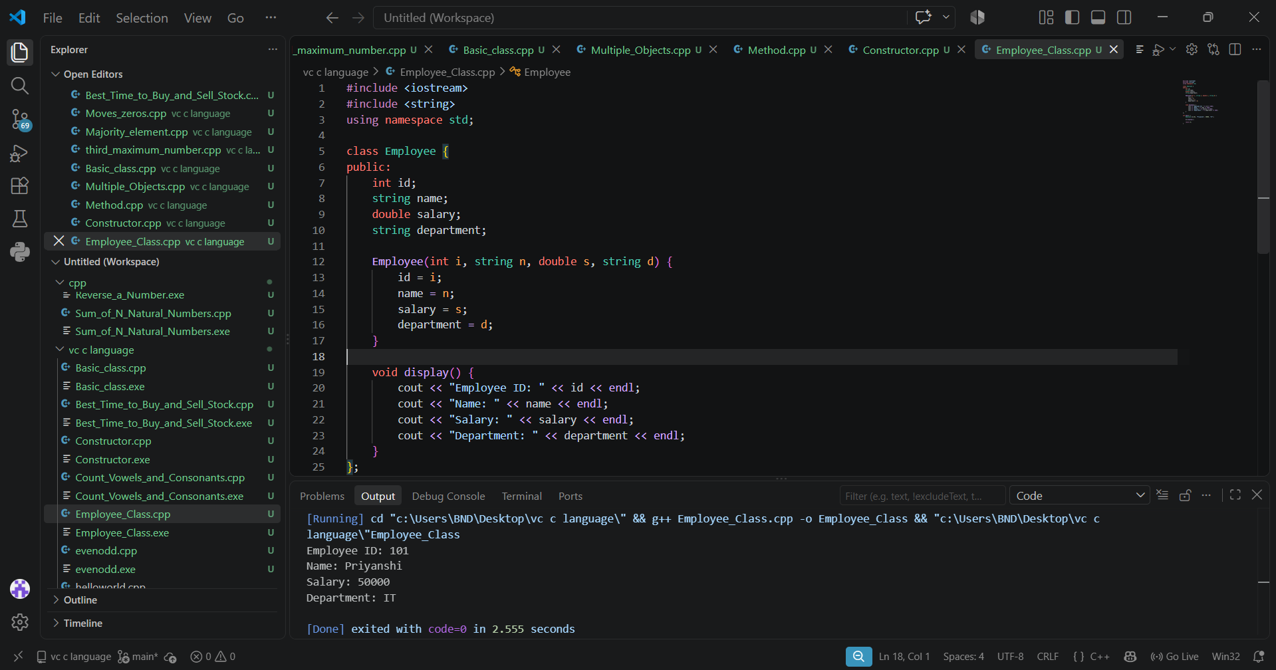
Exercise 6 — BankAccount
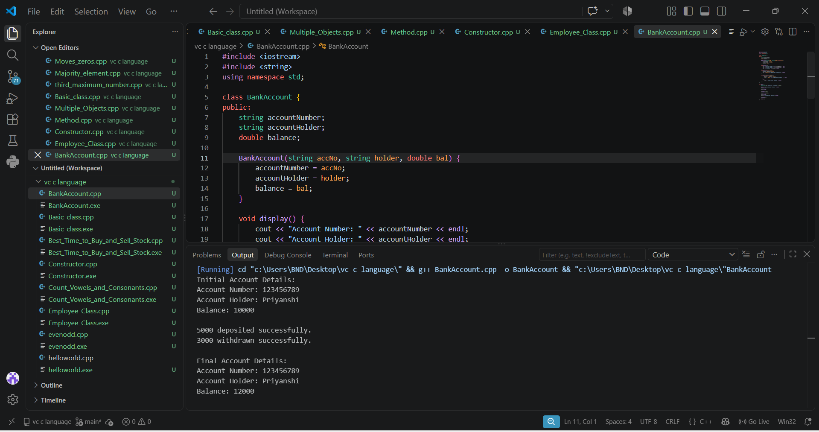

other leetcoe problem
- Remove_Duplicates_from_Sorted_Array
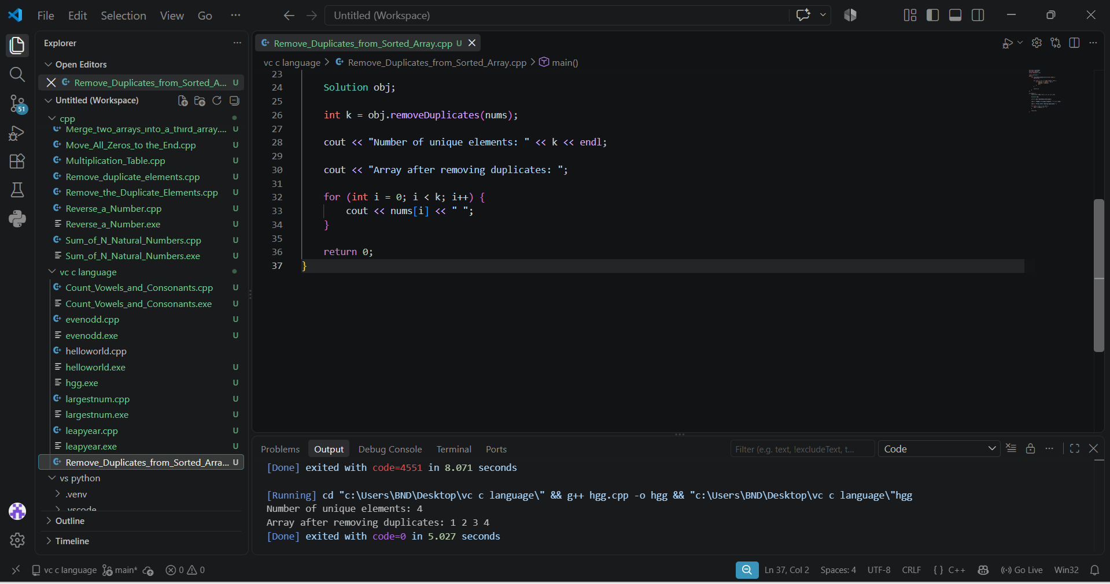
2.Best Time to Buy and Sell Stock
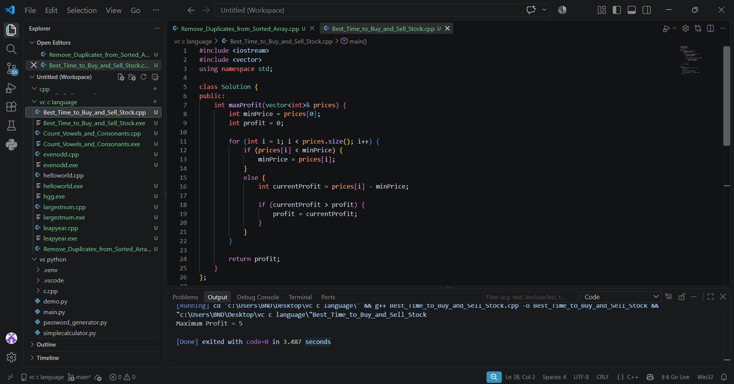
- Moves Zeros
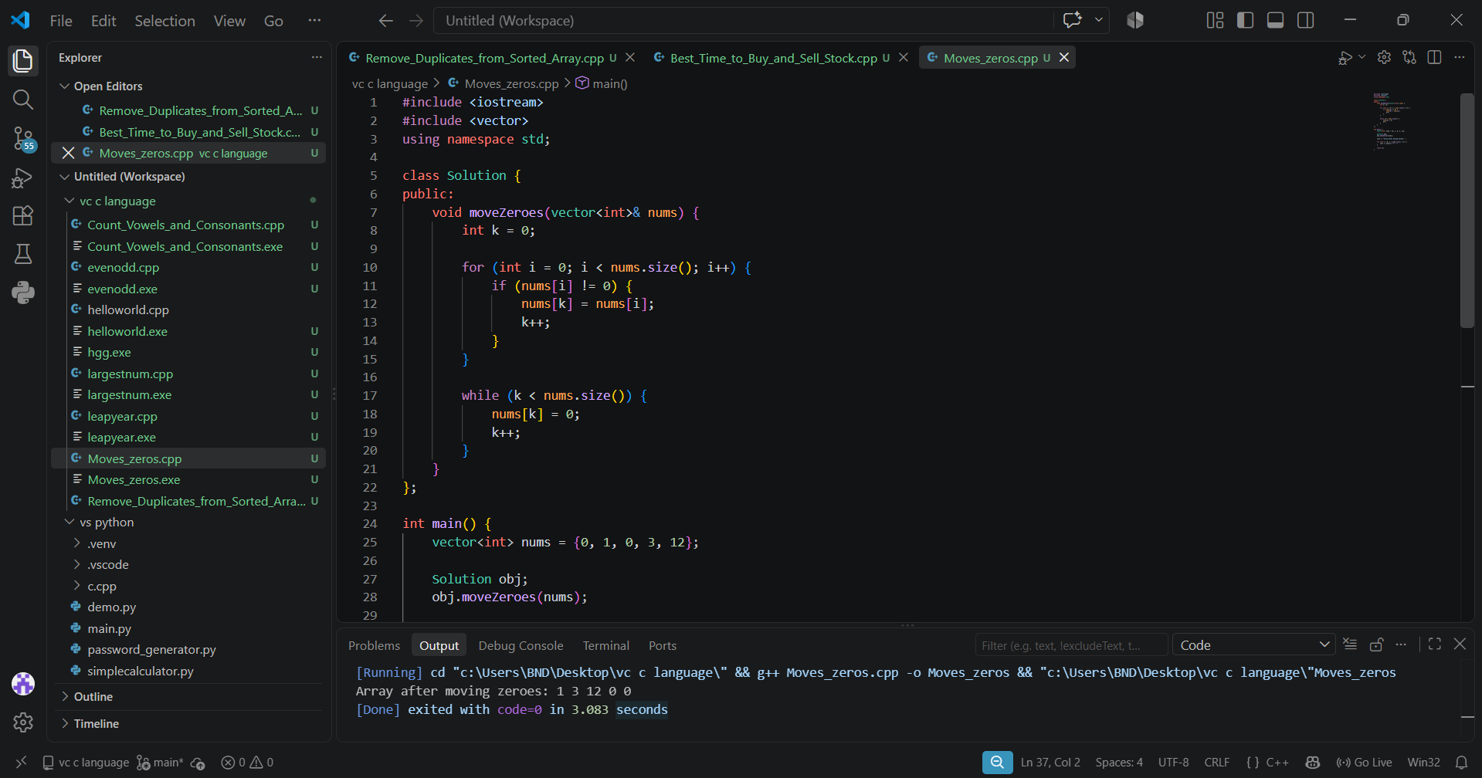

- Majority element
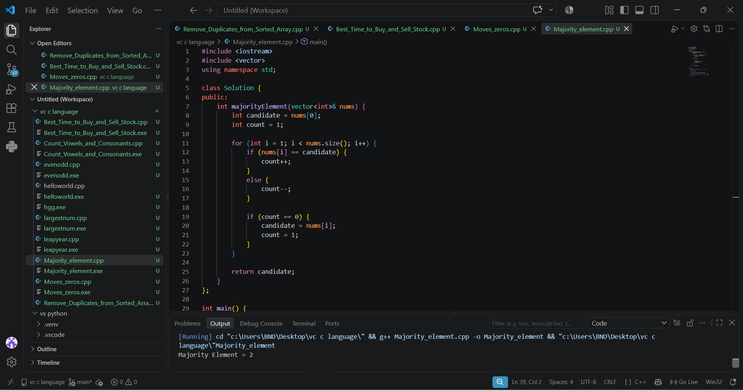

- Third Maximum number
